**10 SCIENCE 2015**

### BIOLOGY TEST TWO

Name: ____________________ Teacher: ___________________ Mark: /48

**Percentage: %**

**SECTION A: MULTIPLE CHOICE (5 marks)**

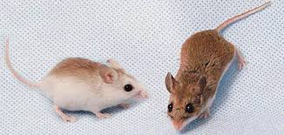

**Select the best answer for each question below.**

*Answer question 1 and 2 using the information and table below.*

A biologist who was studying a population of mice that lived in an area with few trees and scattered low shrubs separated from each other by large areas of bare soil. He found that the mice had two genes that controlled their coat colour. One tended to give the coat a dark-brown colour, while the other produced a lighter yellowish brown colour.

The area contained three different soil types: dark red clay, pale yellow sand and light grey sand. Studies of the proportion of mice with the different coat colour were done and are shown in the table. There are was a very dry semi-desert climate. The mice were preyed upon by hawks that hunted mainly in the morning and late afternoon.

|  |  |  |  |
| --- | --- | --- | --- |
| Site | Soil colour | Per cent of mice with brown coat | Per cent of mice with yellowish coat |
| 1 | Red | 82 | 18 |
| 2 | Light grey | 52 | 48 |
| 3 | Pale yellow | 41 | 59 |

**1.** Which of the following is a fair interpretation of the data?

(a) There are more brown-coated mice than yellow-coated mice in the population.

(b) Brown coats are more suited to red clay than they are to light-grey sand.

(c) Yellowish coats are more suited to the light-grey sand.

(d) Brown-coated mice are moving from pale-yellow sand and light-grey sand to the red clay.

**2.** Considering the information in the table, which of the following conclusions is likely?

(a) Hawks always prefer to eat mice with a yellowish coat colour.

(b) The climate is selecting for lighter coloured mice because they will absorb less heat.

(c) The coat colour provides the mice with camouflage protection from the hawk.

(d) Light colour soil selects for the yellowish coat colour.

**3.** Choose the genotype of a homozygous individual.

(a) r.

(b) RR.

(c) Rr.

(d) R.

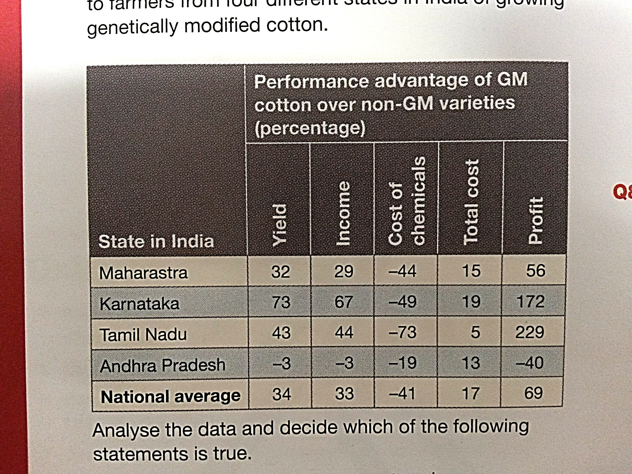**4.** The data in the table provides information on the

costs to farmers from four different states in

India of growing genetically modified cotton.

Analyse the data and decide which of the following statements is true.

(a) The state that made the greatest savings on chemicals also had the highest yield and the greatest profit.

(b) The states of Maharastra and Kamataka both saved more than the national average on chemical costs and had a yield and profit above the national average.

(c) The state that had the greatest advantage in terms of total income also had the greatest advantage in terms of total cost and yield.

(d) Andhra Pradesh made a loss because the farmers in that state had to spend more on chemicals.

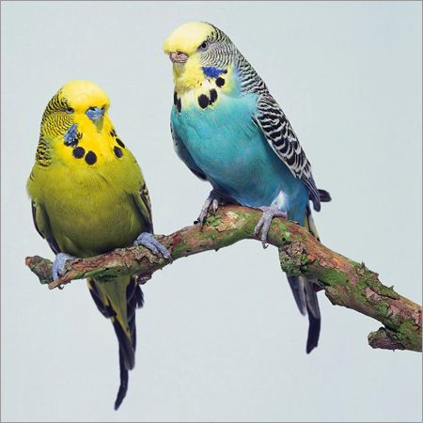**5.** In budgerigars, green feather colour (G) is dominant to blue feather colour (g). A

blue male budgerigar is mated with a heterozygous female budgerigar. Identify

the most probably genotypes of the offspring.

(a) All the offspring will be blue.

(b) All the offspring will be green.

(c) ½ Gg, ½ gg.

(d) ½ GG, ½ gg.

**SECTION B: SHORT ANSWER (45 marks)**

**1.** **Name** the first person to propose the process of natural selection. (1 mark)

______________________________________________________________________________________

**2.** **Name** the Austrian monk who carried out experiments on pea plants in 1856. (1 mark)

______________________________________________________________________________________

**3.** Write a **definition** for the term ‘pure-breeding’. (2 marks)

______________________________________________________________________________________

______________________________________________________________________________________

______________________________________________________________________________________

______________________________________________________________________________________

**4.** **Explain** how light-coloured peppered moths gradually died out in the cities where pollution had changed the environment. (3 marks)

______________________________________________________________________________________

______________________________________________________________________________________

______________________________________________________________________________________

______________________________________________________________________________________

______________________________________________________________________________________

______________________________________________________________________________________

______________________________________________________________________________________

______________________________________________________________________________________

**5.** **List** two examples of biotic selective factors. (2 marks)

______________________________________________________________________________________

**6.** **List** two examples of physical selective factors. (2 marks)

______________________________________________________________________________________

**5.**

**7.** Spraying crops with pesticides has caused the development of pesticide-resistant insects. This is given as an example of natural selection even though humans are involved in the spraying.

**Identify** the selective agent for natural selection in this case. (1 mark)

______________________________________________________________________________________

**8.** Chemicals made by organisms to defend them against bacteria are known as: (1 mark)

______________________________________________________________________________________

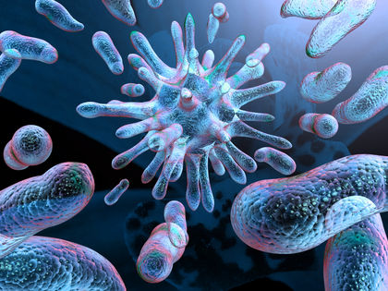

Different types of bacteria

**9.** The process where an environmental factor acts on a population and results in some organisms having more offspring than others is known as: (1 mark)

______________________________________________________________________________________

**10.** **Circle** either ‘true’ or ‘false’ for the following statements. (3 marks)

Individuals that are poorly suited to their environment True False

are the most likely to survive to reproduce.

Sexual selection is a type of natural selection. True False

Mutations can be caused by mutagens. True False

Predation is an example of a selective agent. True False

Genes are inherited. True False

Characteristics that can be physically seen are known as genotypes. True False

**11.** **Explain** how the male determines the sex of the child. (2 marks)

______________________________________________________________________________________

______________________________________________________________________________________

______________________________________________________________________________________

______________________________________________________________________________________

______________________________________________________________________________________

______________________________________________________________________________________

______________________________________________________________________________________

**12.** The images below are both examples of _______________________________________ (1 mark)

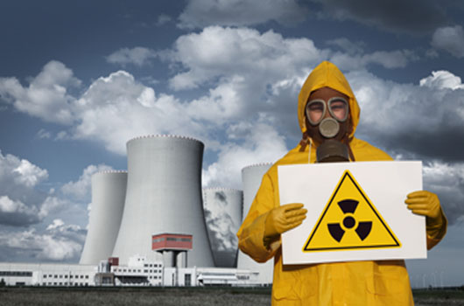

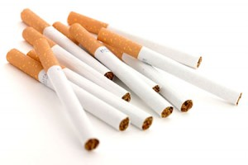

**13.** When a mutation occurs in the eggs or sperm, sometimes the mutation can be passed on to the

next generation. This type of mutation is called ______________________ mutation. (1 mark)

**14.** Contrast homozygous and heterozygous. (2 marks)

______________________________________________________________________________________

______________________________________________________________________________________

______________________________________________________________________________________

______________________________________________________________________________________

**15.**  In guinea pigs, black fur is dominant over brown fur. Show the cross of a heterozygous black male with a homozygous brown female. (5 marks)

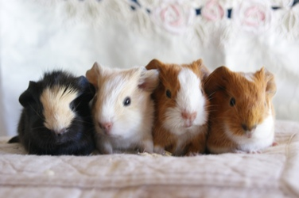

**Parents**

Male genotype: _______________ Male phenotype: _________________________________

Female genotype: ______________ Female phenotype: _______________________________

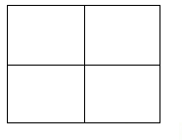

**Offspring**

Genotype: ______________________________________________________________________________

_______________________________________________________________________________________

Phenotype: _____________________________________________________________________________

_______________________________________________________________________________________

**16.** Write a definition for the term mutagen. (2 marks)

_______________________________________________________________________________________

_______________________________________________________________________________________

_______________________________________________________________________________________

_______________________________________________________________________________________

**17.** Fill in the missing words below. (2 marks)

One very dangerous type of bacteria is __________________ _________________ (Staphylococcus aureus), which is resistant to many antibodies and is very difficult to __________. It became resistant because of the widespread use of ______________________ in hospitals.

**18.** Write the correct letter next to the matching description. (4 marks)

|  |  |  |
| --- | --- | --- |
| Symbol/name | Description | Matching letter |
| **a)** Mm | A dominant allele |  |
| **b)** XY | Another name for gene |  |
| **c)** M | Genotype of a homozygous individual |  |
| **d)** PP | Genotype of a male individual |  |
| **e)** Red flower | Genotype of a heterozygous individual |  |
| **f)** a | Genotype of a female individual |  |
| **g)** XX | A recessive allele |  |
| **h)** Allele | A phenotype |  |

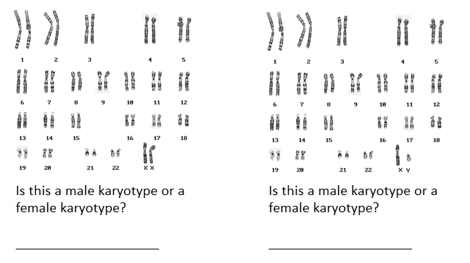**19.** **Circle** the sex chromosomes on each karyotype and **state** whether it is a male or female karyotype. (2 marks)

**20.** Fill in the missing words below. (4 marks)

Females have sex cells known as _________. These sex cells have an ____ chromosome. Males have sex cells known as __________. These sex cells can either carry an _______ chromosome or a _______ chromosome. A daughter will always get one ______ chromosome from her mother and the ______ chromosome from her father. This would produce _______.

**21.** The inherited ability of an organism to withstand chemicals is known as (1 mark)

______________________________________________________________________________________